# Twist and Turn

The best way to turn a breeched baby…

Acupuncture or External cephalic Version?

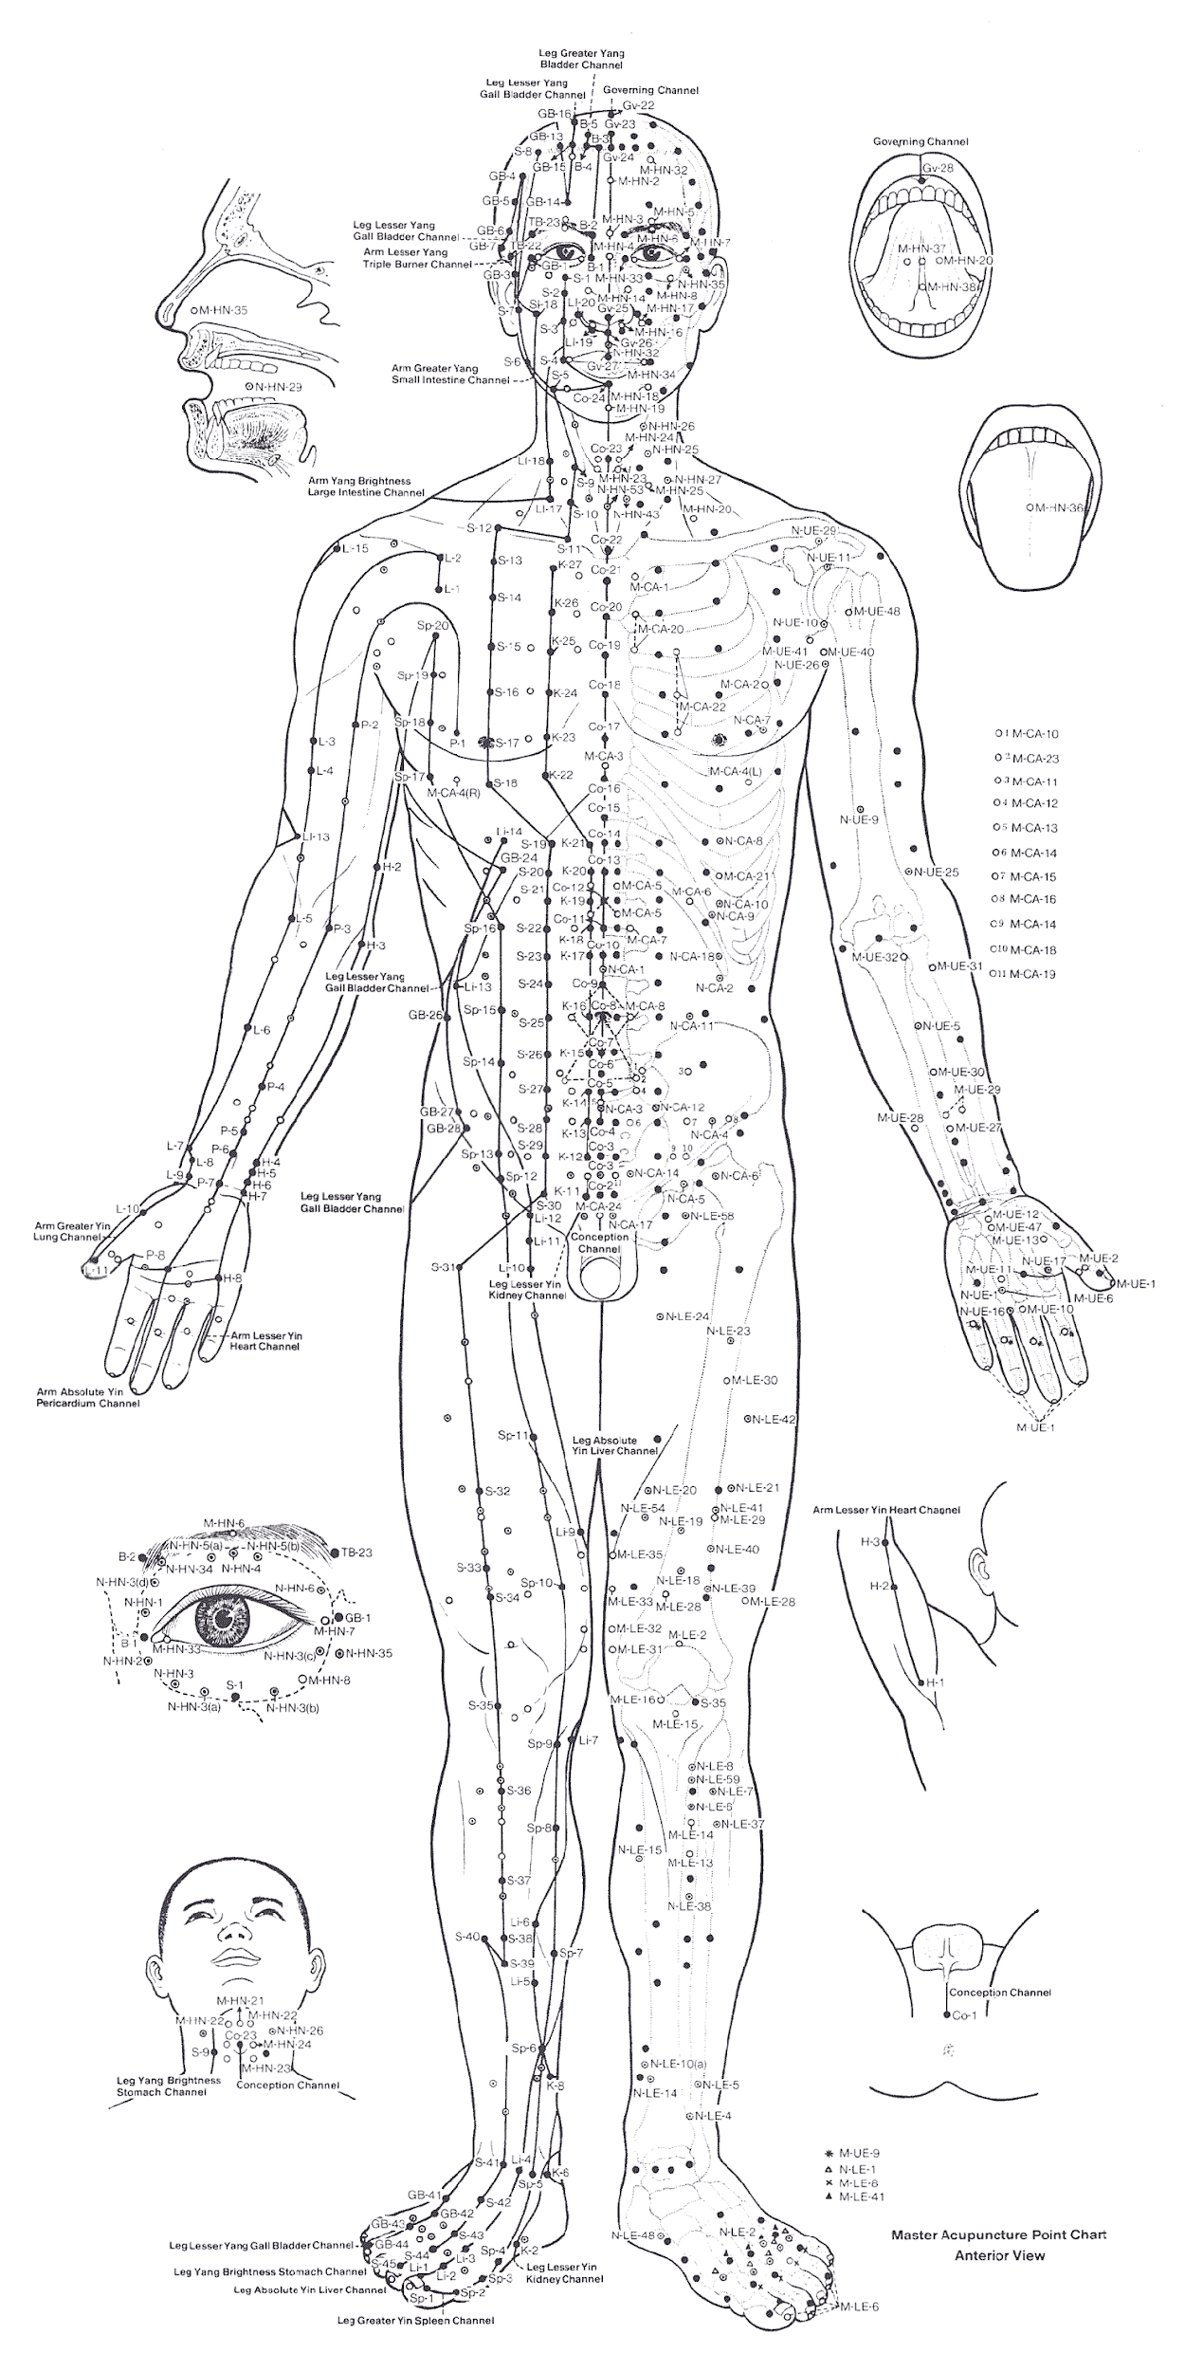

A Senior Project and AP Biology Portfolio

By: Cassandra Davis

Amador Valley High School

Health and Bioscience Academy

2003

